
National
University
of
Computer
and
Emerging
Sciences
Chiniot-Faisalabad
Campus
CL2001 – Data Structures - Lab
Lab 9
“BST”
Fall 2024
Maximum Marks: 100 Due Date: 20 October 2024
Submitted By
Name: | Talha Abdullah
Student ID: | 22F-3194
Section: | BAI-3A
Submitted To
Muhammad Yousaf
Lecturer – AI & Data Science Department
Submission Date
20 October 2024

Problem 1

Source Code
#include <iostream>
using namespace std;

struct Node {
int data;
Node* left;
Node* right;

Node(int value) {
data = value;
left = nullptr;
right = nullptr;
}
};

class BST {
public:
Node* insert(Node* root, int value) {
if (root == nullptr) {
return new Node(value);
}
if (value < root->data) {
root->left = insert(root->left, value);
} else if (value > root->data) {
root->right = insert(root->right, value);
}
return root;
}

Node* find(Node* root, int value) {
if (root == nullptr || root->data == value) {
return root;
}
if (value > root->data) {
return find(root->right, value);
}
return find(root->left, value);
}

Node* findMin(Node* root) {
while (root && root->left != nullptr) {
root = root->left;
}
return root;
}

Node* deleteNode(Node* root, int value) {
if (root == nullptr) {
return root;
}
if (value < root->data) {
root->left = deleteNode(root->left, value);
} else if (value > root->data) {
root->right = deleteNode(root->right, value);
} else {
if (root->left == nullptr) {
Node* temp = root->right;
delete root;
return temp;
} else if (root->right == nullptr) {
Node* temp = root->left;
delete root;
return temp;
}
Node* temp = findMin(root->right);
root->data = temp->data;
root->right = deleteNode(root->right, temp->data);
}
return root;
}

void inorder(Node* root) {
if (root != nullptr) {
inorder(root->left);
cout << root->data << " ";
inorder(root->right);
}
}
};

int main() {
BST bst;
Node* root = nullptr;
Node* foundNode = nullptr;
int choice, value;

while (true) {
cout << "----------Menu----------" << endl;
cout << "1. Insert in Tree" << endl;
cout << "2. Search in Tree" << endl;
cout << "3. Delete in Tree" << endl;
cout << "4. Inorder Traversal in Tree" << endl;
cout << "0. Exit the code" << endl;
cout << "Enter your choice: ";
cin >> choice;

switch (choice) {
case 1:
cout << "Enter value to insert: ";
cin >> value;
root = bst.insert(root, value);
break;
case 2:
cout << "Enter value to search: ";
cin >> value;
foundNode = bst.find(root, value);
if (foundNode) {
cout << "Node " << value << " found in the tree." << endl;
} else {
cout << "Node " << value << " not found in the tree." << endl;
}
break;
case 3:
cout << "Enter value to delete: ";
cin >> value;
root = bst.deleteNode(root, value);
cout << "Node " << value << " deleted from the tree." << endl;
break;
case 4:
cout << "Inorder traversal of the tree: ";
bst.inorder(root);
cout << endl;
break;
case 0:
cout << "Exiting..." << endl;
return 0;
default:
cout << "Invalid choice. Please try again." << endl;
}
}

return 0;
}

Screenshot
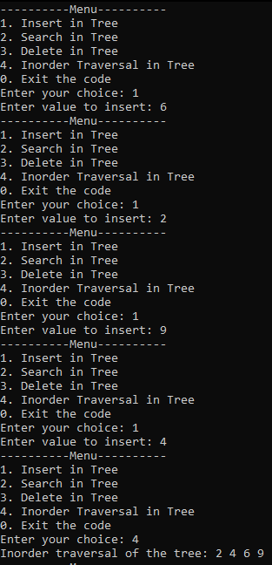
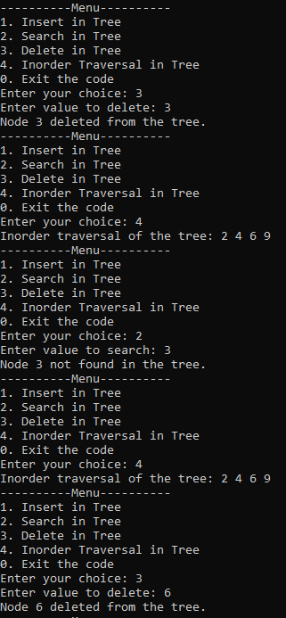
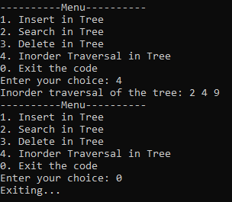

Problem 2

Source Code
#include <iostream>
using namespace std;

struct Node {
int data;
Node* left;
Node* right;

Node(int value) {
data = value;
left = nullptr;
right = nullptr;
}
};

class BST {
public:
Node* insert(Node* root, int value) {
if (root == nullptr) {
return new Node(value);
}
if (value < root->data) {
root->left = insert(root->left, value);
}
else if (value > root->data) {
root->right = insert(root->right, value);
}
return root;
}

void inorder(Node* root) {
if (root != nullptr) {
inorder(root->left);
cout << root->data << " ";
inorder(root->right);
}
}

int sumOfLeafNodes(Node* root) {
if (root == nullptr) {
return 0;
}
if (root->left == nullptr && root->right == nullptr) {
return root->data;
}
return sumOfLeafNodes(root->left) + sumOfLeafNodes(root->right);
}
};

int main() {
BST bst;
Node* root = nullptr;
int choice, value;

while(true) {
cout << "----------Menu---------" << endl;
cout << "1. Insert" << endl;
cout << "2. Inorder Traversal" << endl;
cout << "3. Sum of Leaf Nodes" << endl;
cout << "0. Exit" << endl;
cout << "Enter your choice: ";
cin >> choice;

switch (choice) {
case 1:
cout << "Enter value to insert: ";
cin >> value;
root = bst.insert(root, value);
break;

case 2:
cout << "Inorder traversal of the tree: ";
bst.inorder(root);
cout << endl;
break;

case 3:
cout << "Sum of all leaf nodes: " << bst.sumOfLeafNodes(root) << endl;
break;

case 0:
cout << "Exiting..." << endl;
return 0;

default:
cout << "Invalid choice. Please try again." << endl;
}
}

return 0;
}

Screenshot
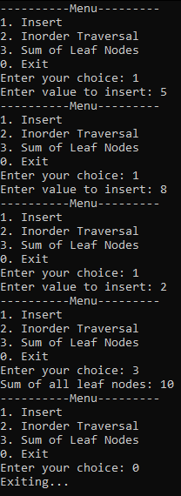

Problem 3

Source Code
#include <iostream>
using namespace std;

struct Node {
int data;
Node* left;
Node* right;

Node(int value) {
data = value;
left = nullptr;
right = nullptr;
}
};

class BST {
public:
Node* insert(Node* root, int value) {
if (root == nullptr) {
return new Node(value);
}
if (value < root->data) {
root->left = insert(root->left, value);
}
else if (value > root->data) {
root->right = insert(root->right, value);
}
return root;
}

void inorder(Node* root) {
if (root != nullptr) {
inorder(root->left);
cout << root->data << " ";
inorder(root->right);
}
}

void printLevel(Node* root, int k) {
if (root == nullptr) {
return;
}
if (k == 0) {
cout << root->data << " ";
return;
}
printLevel(root->left, k - 1);
printLevel(root->right, k - 1);
}

Node* deleteLevel(Node* root, int k) {
if (root == nullptr) {
return nullptr;
}
if (k == 0) {
delete root;
return nullptr;
}
root->left = deleteLevel(root->left, k - 1);
root->right = deleteLevel(root->right, k - 1);
return root;
}
};

int main() {
BST bst;
Node* root = nullptr;
int choice, value, level;

while(true) {
cout << "----------Menu----------" << endl;
cout << "1. Insert" << endl;
cout << "2. Inorder Traversal" << endl;
cout << "3. Print Nodes at Level K" << endl;
cout << "4. Delete Nodes at Level K" << endl;
cout << "0. Exit" << endl;
cout << "Enter your choice: ";
cin >> choice;

switch (choice) {
case 1:
cout << "Enter value to insert: ";
cin >> value;
root = bst.insert(root, value);
break;

case 2:
cout << "Inorder traversal of the tree: ";
bst.inorder(root);
cout << endl;
break;

case 3:
cout << "Enter level to print: ";
cin >> level;
cout << "Nodes at level " << level << ": ";
bst.printLevel(root, level);
cout << endl;
break;

case 4:
cout << "Enter level to delete: ";
cin >> level;
cout << "Deleting nodes at level " << level << "..." << endl;
root = bst.deleteLevel(root, level);
cout << "Nodes at level " << level << " deleted." << endl;
break;

case 0:
cout << "Exiting..." << endl;
return 0;

default:
cout << "Invalid choice. Please try again." << endl;
}
}

return 0;
}

Screenshot
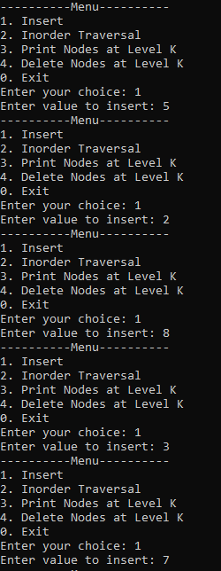
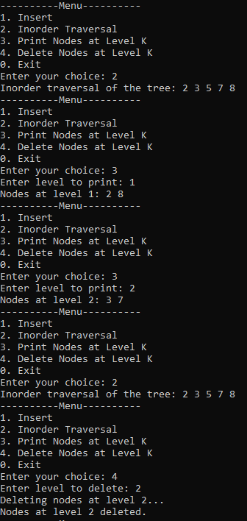
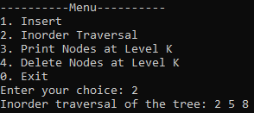

Problem 4

Source Code
#include <iostream>
#include <cmath>
using namespace std;

struct Node {
int data;
Node* left;
Node* right;

Node(int value) {
data = value;
left = nullptr;
right = nullptr;
}
};

class BST {
public:
Node* insert(Node* root, int value) {
if (root == nullptr) {
return new Node(value);
}
if (value < root->data) {
root->left = insert(root->left, value);
}
else if (value > root->data) {
root->right = insert(root->right, value);
}
return root;
}

void inorder(Node* root) {
if (root != nullptr) {
inorder(root->left);
cout << root->data << " ";
inorder(root->right);
}
}

int closestValue(Node* root, int key) {
int closest = root->data;
return findClosest(root, key, closest);
}

private:
int findClosest(Node* root, int key, int closest) {
if (root == nullptr) {
return closest;
}
if (abs(root->data - key) < abs(closest - key)) {
closest = root->data;
}
if (key < root->data) {
return findClosest(root->left, key, closest);
}
else if (key > root->data) {
return findClosest(root->right, key, closest);
}
return closest;
}
};

int main() {
BST bst;
Node* root = nullptr;
int choice, value, key, closest;

while(true) {
cout << "----------Menu----------" << endl;
cout << "1. Insert" << endl;
cout << "2. Inorder Traversal" << endl;
cout << "3. Find Closest Value" << endl;
cout << "0. Exit" << endl;
cout << "Enter your choice: ";
cin >> choice;

switch (choice) {
case 1:
cout << "Enter value to insert: ";
cin >> value;
root = bst.insert(root, value);
break;

case 2:
cout << "Inorder traversal of the tree: ";
bst.inorder(root);
cout << endl;
break;

case 3:
cout << "Enter key to find closest value: ";
cin >> key;
closest = bst.closestValue(root, key);
cout << "Closest value to " << key << " is: " << closest << endl;
break;

case 0:
cout << "Exiting..." << endl;
return 0;

default:
cout << "Invalid choice. Please try again." << endl;
}
}

return 0;
}

Screenshot
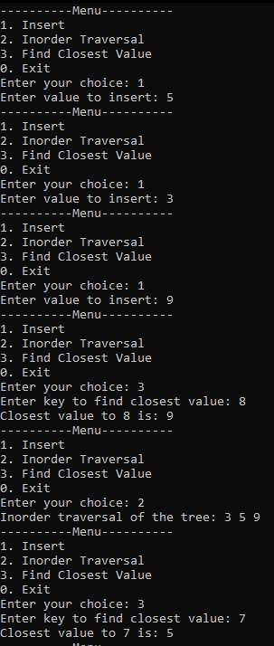

Problem 5

Source Code
#include <iostream>
using namespace std;

struct Node {
int data;
Node* left;
Node* right;

Node(int value) {
data = value;
left = nullptr;
right = nullptr;
}
};

class BST {
public:
Node* insert(Node* root, int value) {
if (root == nullptr) {
return new Node(value);
}
if (value < root->data) {
root->left = insert(root->left, value);
}
else if (value > root->data) {
root->right = insert(root->right, value);
}
return root;
}

void inorder(Node* root) {
if (root != nullptr) {
inorder(root->left);
cout << root->data << " ";
inorder(root->right);
}
}

bool isIdentical(Node* root1, Node* root2) {
if (root1 == nullptr && root2 == nullptr) {
return true;
}
if (root1 == nullptr || root2 == nullptr) {
return false;
}
return (root1->data == root2->data) &&
isIdentical(root1->left, root2->left) &&
isIdentical(root1->right, root2->right);
}
};

int main() {
BST bst;
Node* root1 = nullptr;
Node* root2 = nullptr;
int choice, value;

while (true) {
cout << "--------------Menu--------------";
cout << "1. Insert into Tree 1" << endl;
cout << "2. Insert into Tree 2" << endl;
cout << "3. Inorder Traversal of Tree 1" << endl;
cout << "4. Inorder Traversal of Tree 2" << endl;
cout << "5. Check if Trees are Identical" << endl;
cout << "0. Exit" << endl;
cout << "Enter your choice: ";
cin >> choice;

switch (choice) {
case 1:
cout << "Enter value to insert into Tree 1: ";
cin >> value;
root1 = bst.insert(root1, value);
break;

case 2:
cout << "Enter value to insert into Tree 2: ";
cin >> value;
root2 = bst.insert(root2, value);
break;

case 3:
cout << "Inorder traversal of Tree 1: ";
bst.inorder(root1);
cout << endl;
break;

case 4:
cout << "Inorder traversal of Tree 2: ";
bst.inorder(root2);
cout << endl;
break;

case 5:
if (bst.isIdentical(root1, root2)) {
cout << "The two trees are structurally identical." << endl;
}
else {
cout << "The two trees are NOT structurally identical." << endl;
}
break;

case 0:
cout << "Exiting..." << endl;
return 0;

default:
cout << "Invalid choice. Please try again." << endl;
}
}

return 0;
}

Screenshot

